Design Review

* Robot with reloading shooter concept

horizontal line **Date:** Sunday, Jan 29, 2017

**Reference:** Slack Discussion, Jan 29, Building Channel

**Attendees**

Chandler, Mentor George, open channel to team

|  |  |  |  |
| --- | --- | --- | --- |
| **Major Milestones:** |  | **Completion Goal** | **Completed** |
| Determined Tigers Qualifier – West Hartford |  | Feb 4, 2017 |  |
| Battle at the Beach – CT State Championship |  | Feb 18, 2017 | Qualified |
| East Super Regional – Scranton, PA |  | Mar 17-19, 2017 |  |
| Worlds Competition |  | Apr 2017 |  |
| Post competition – Hatter’s Scrimmage |  | May 16, 2017 |  |

**Notes**

***Agenda:***

* Review initial CAD, sweeper redesign

***Current issues:***

* Beacon pusher needs to be quicker, more rugged.
* Need two beacon pushers
* Need a particle shooter
* Need particle re-loading to shoot multiple times

***Observations:***

* Initial concept for the robot included particle re-loader. See figure 1.
* Re-loader involves physical layout of the whole robot, providing for pathways for the particles to travel from pickup to some control station that regulates feeding the particles to the shooter one at a time.
* Often the sweeper arrangement is done with belts, or rotating shafts with brushes or surgical tubing.

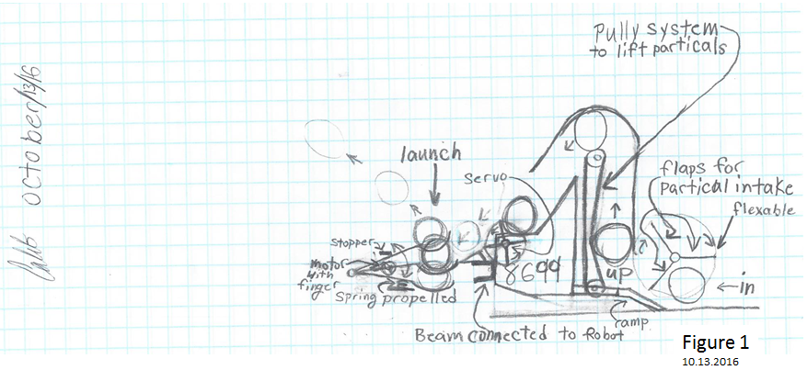

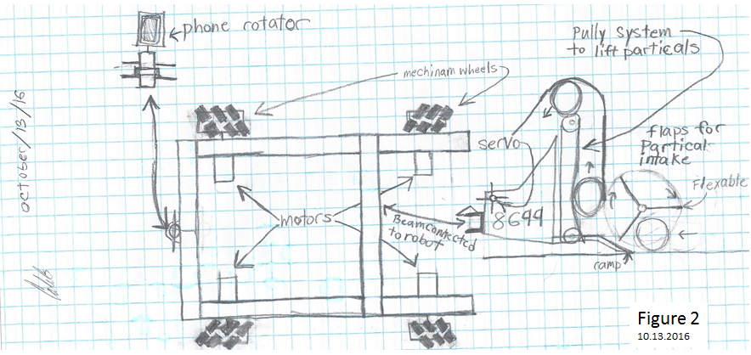

***Suggested concepts for improvement:***

* Robot redesign/re-arrangement per the following images:

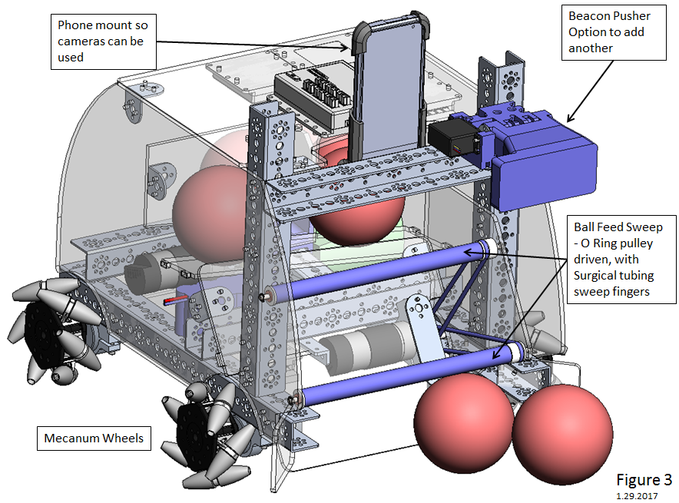 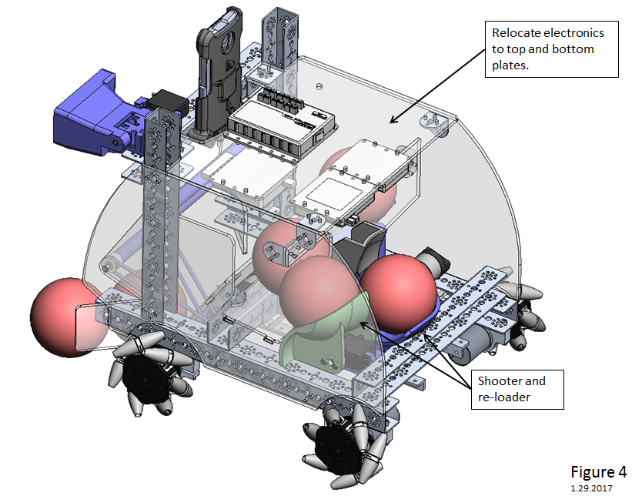

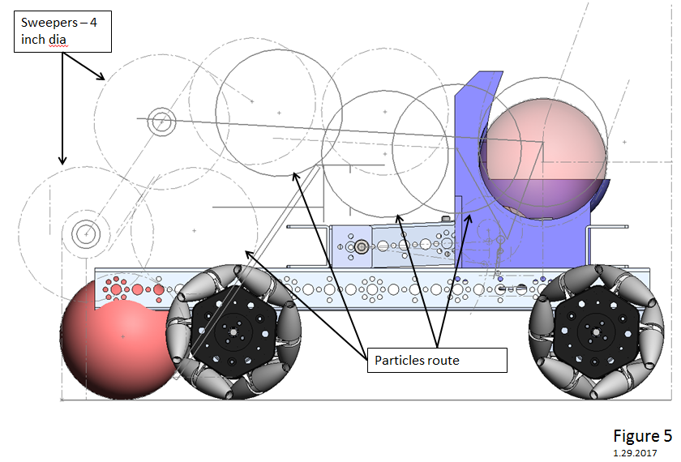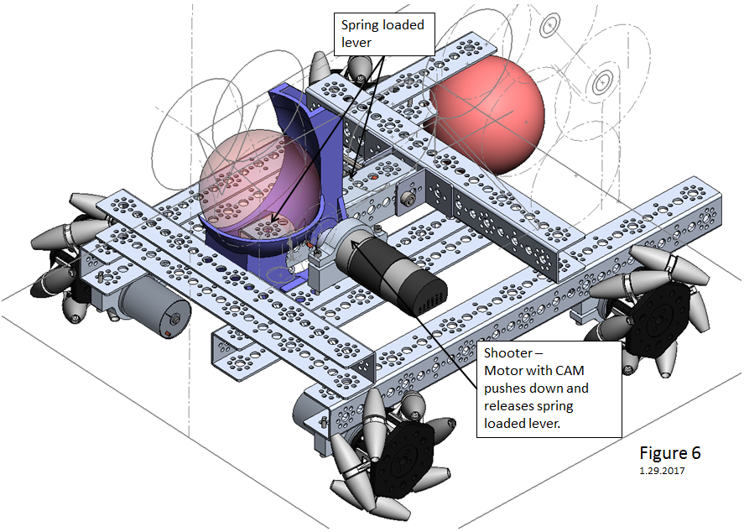 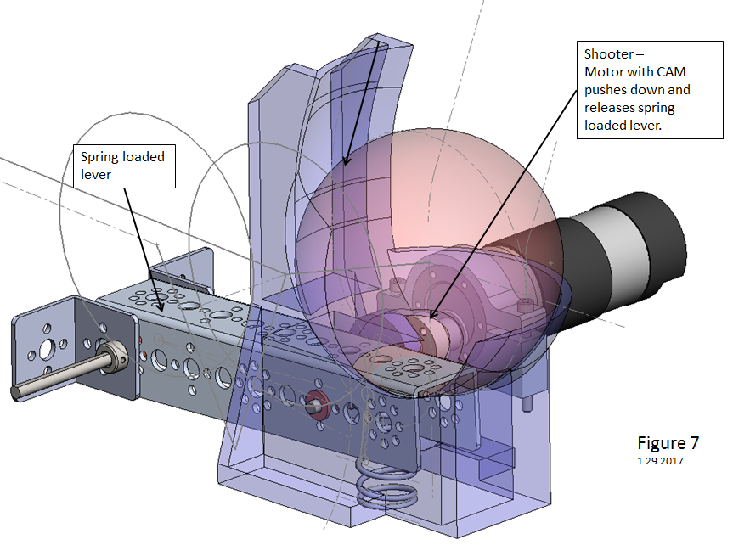

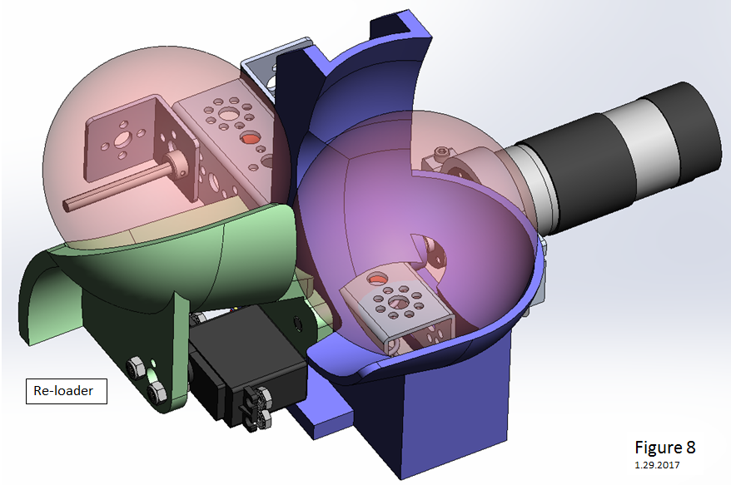

***Review comments:***

* Proceed with design and fabricate parts

|  |  |  |
| --- | --- | --- |
| **Action Items** | **Assigned** | **Date/Goal** |
| Finish design – screw locations, controller locations, additional electronic components (multiplex board, etc.), phone mount | Chandler | 2/10 |
| Fab parts, laser cut plastic | Chandler, at Nexus | 2/12 |
| Fab parts, printed plastic | Chandler, at Nexus | 2/12 |

|  |  |  |  |
| --- | --- | --- | --- |
| **Prepared By:** | Chandler | **Date:** | 1.30.2017 |
| **Overview By:** | G. Edward | **Date:** | 1.30.2017 |